**Sankeerth Koppuravuri**

**Z1777808**

**Answers for Database Questions**

**Question 1**: Display the total amount obtained from all the rides

**Importance**: Since we need to know the turnover of the company

**Query**: select sum(bill_amount) as TotalAmount from BILL;

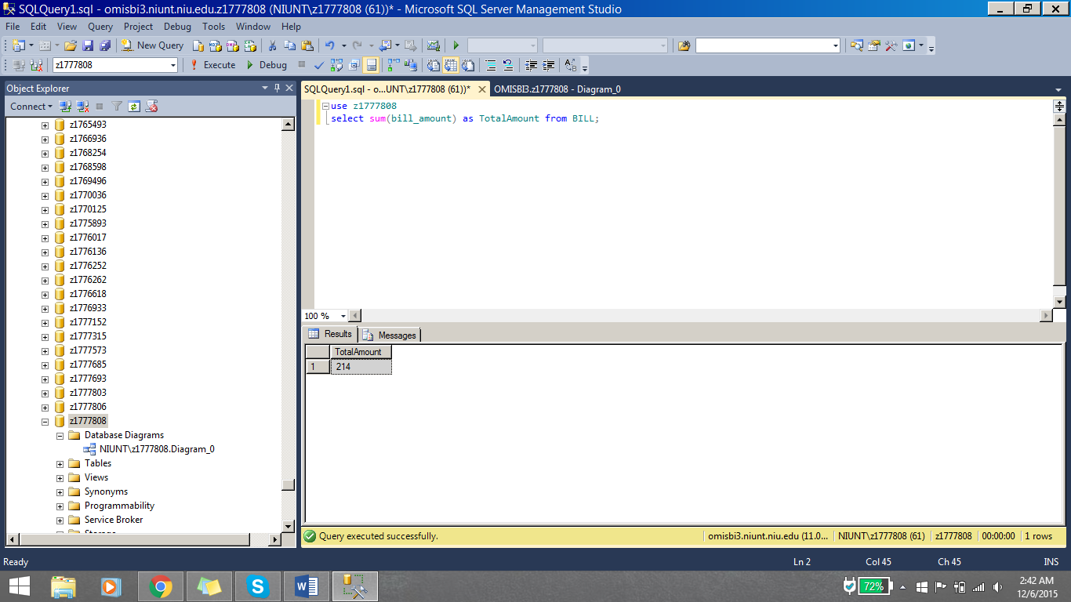

**Question 2**: Display the vehicle which had maximum number of services

**Importance**: Admin needs to know which vehicle requires most services

**Query**: select veh_make, veh_model, count(*) as services from Vehicle v, Service s

where v.Veh_id = s.Veh_id

group by veh_make, veh_model

having count(*) in (select TOP 1 count(*) as services from Vehicle v, Service s

where v.Veh_id = s.Veh_id

group by veh_make, veh_model

order by 1 desc)

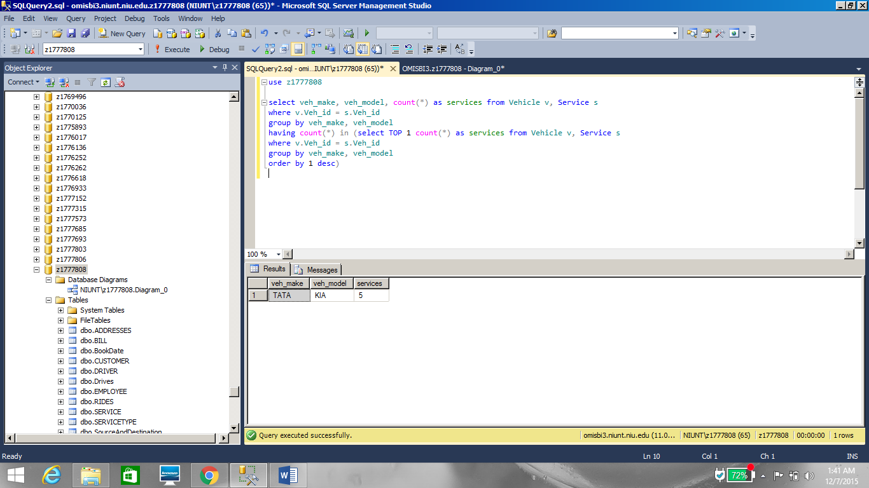

**Question 3**: Display the highest paid employee

**Importance**: Admin is comparing the salaries for tax purposes

**Query**: select Emp_fname, Emp_lname,Emp_salary as HighestSalary from Employee

where Emp_salary in (select Max(Emp_salary) from Employee)

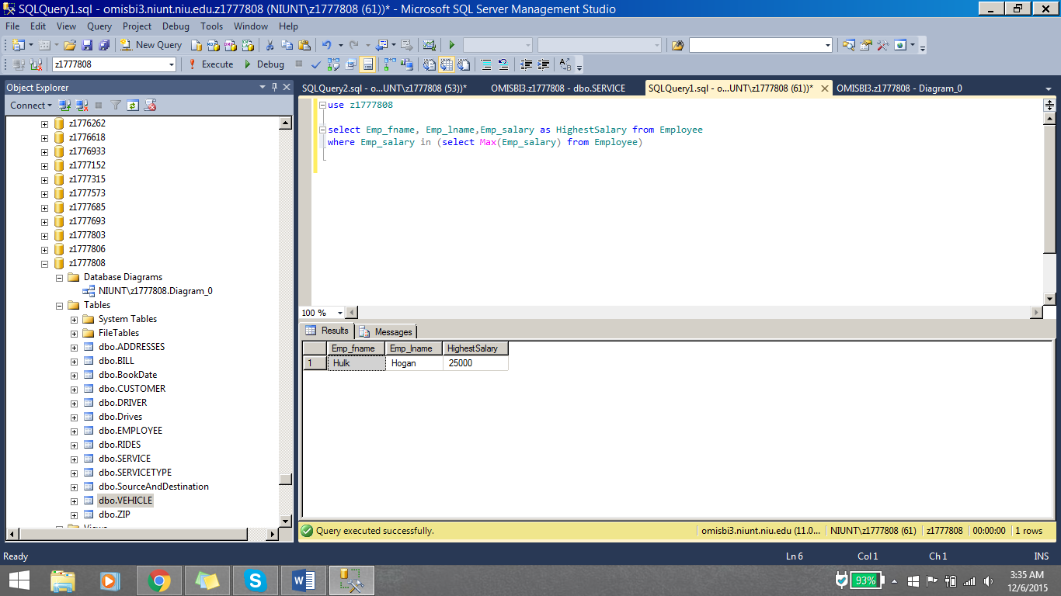

**Question 4**: What is the average amount paid by a customer?

**Importance**: Admin wants to publish this on our company website for marketing purposes

**Query**: select avg(bill_amount) as Average from BILL;

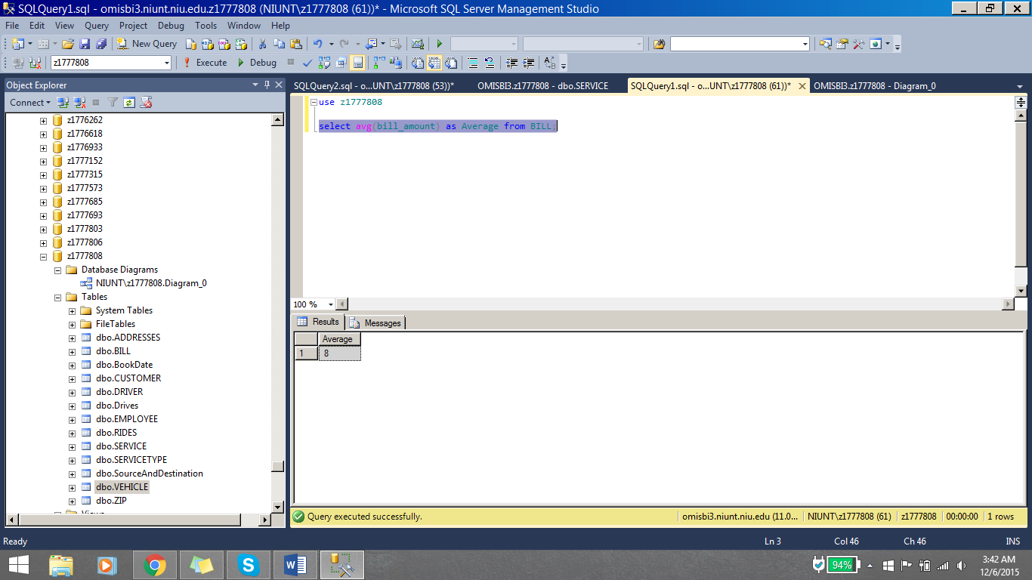

**Question 5**: Display the details of highest paid bill with customer name.

**Importance**: We want to offer discounts or gift cards to these customers when they come for the rides in future

**Query**: select Bill_num, c.Cust_id, cust_fname, cust_lname, ride_id, bill_amount, bill_date from BILL b, CUSTOMER c

where b.Cust_id = c.Cust_id and bill_amount in (select MAX(Bill_amount) from BILL);

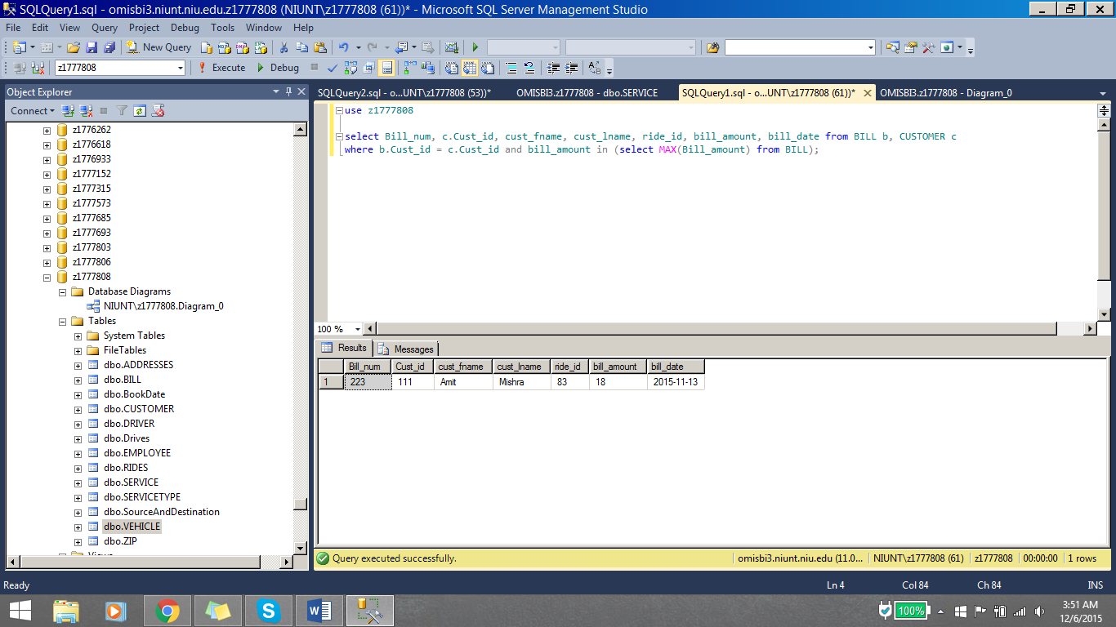

**Question 6**: Display all the Vehicles which are booked on Oct 24th

**Importance**: Because we got a traffic ticket so we are just verifying what vehicles were there on that day

**Query**: select veh_make, veh_model, booking_time from vehicle v, BookDate b

where DATEPART(dd, booking_time) = DATEPART(dd, '2015-10-24') and DATEPART(mm,booking_time) = DATEPART(mm, '2015-10-24')

and DATEPART(yy, booking_time) = DATEPART(yy, '2015-10-24') and v.veh_id = b.veh_id

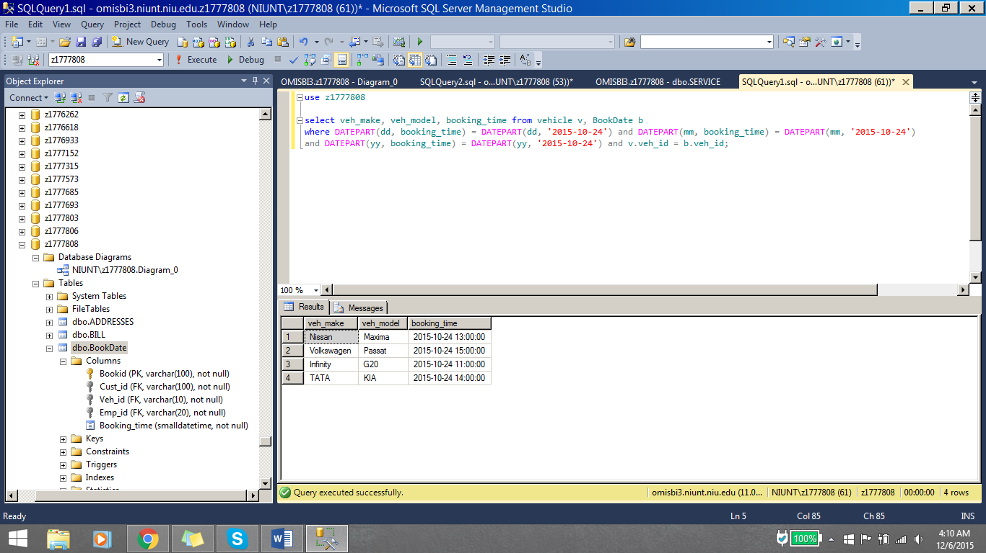

**Question 7**: Display the names of the customers who have booked the rides in between Oct 13th and Oct 20th of this year

**Importance**: Random selection of customers for a satisfactory survey.

**Query**: select cust_fname, cust_lname, booking_time from customer c, bookdate b

where DATEPART(dd, booking_time) > DATEPART(dd, '2015-10-13') and DATEPART(mm, booking_time) = DATEPART(mm, '2015-10-13')

and DATEPART(dd, booking_time) < DATEPART(dd, '2015-10-20')

and DATEPART(mm, booking_time) = DATEPART(mm, '2015-10-20')

and c.cust_id = b.cust_id

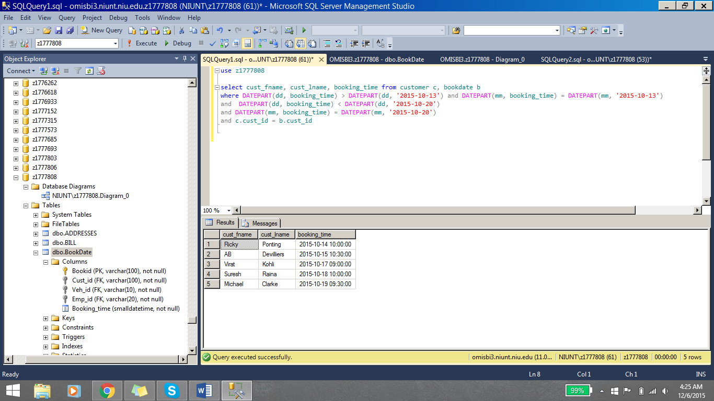

**Question 8**: Display the Customers who live in a place with zip code 60115

**Importance**: Need to inform those customers regarding additional new services in their area.

**Query**: select cust_fname, cust_lname from customer c, ZIP z

where c.Cus_zipcode = z.Zipcode and z.Zipcode = '60115';

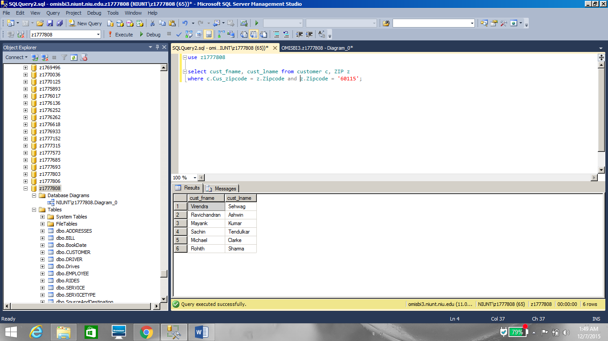

**Question 9**: Display the names of the Drivers who have started their work on Oct 6th 2015

**Importance**: Need to complete their Documentation and paperwork

**Query**: select dr_name from DRIVER d, Drives dr

where d.Dr_id = dr.Dr_id and dr.Start_date = '10-06-2015';

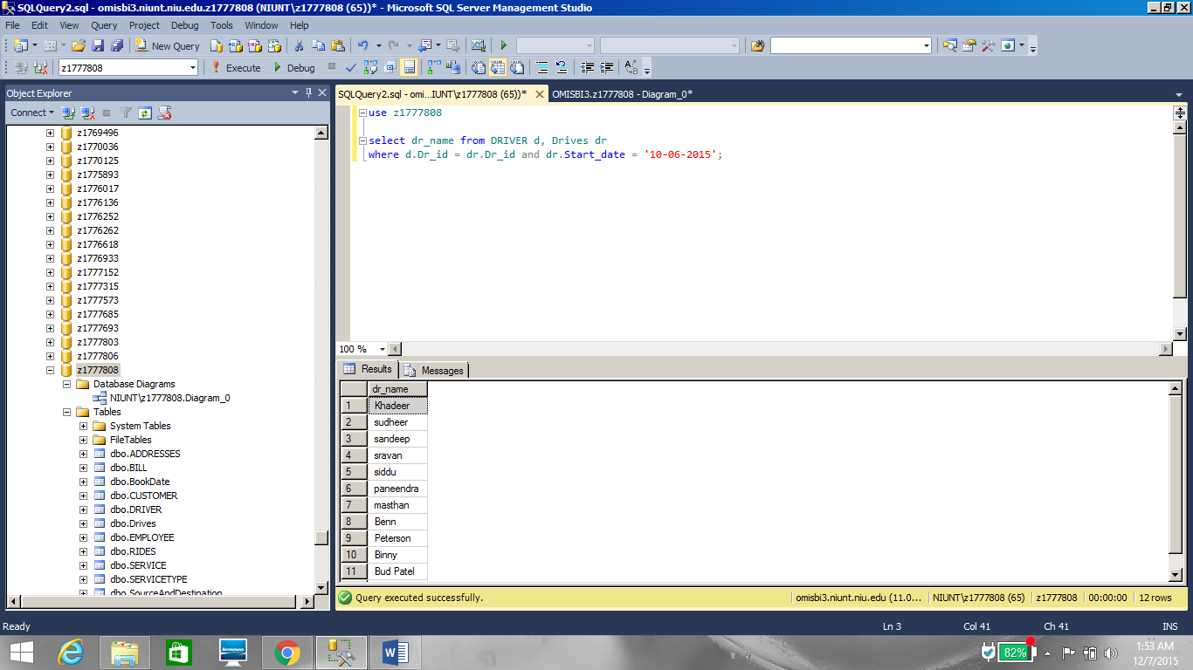

**Question 10**: Display all the vehicles which had gone for a service of speaker change

**Importance**: Consistent complaints about vehicle audio system’s so checking checking which of the vehicles are repaired

**Query**: select veh_make, veh_model from VEHICLE v, SERVICE s, SERVICETYPE st

where v.Veh_id = s.Veh_id and s.Stype_id = st.Stype_id

and st.Stype_name = 'speaker set';

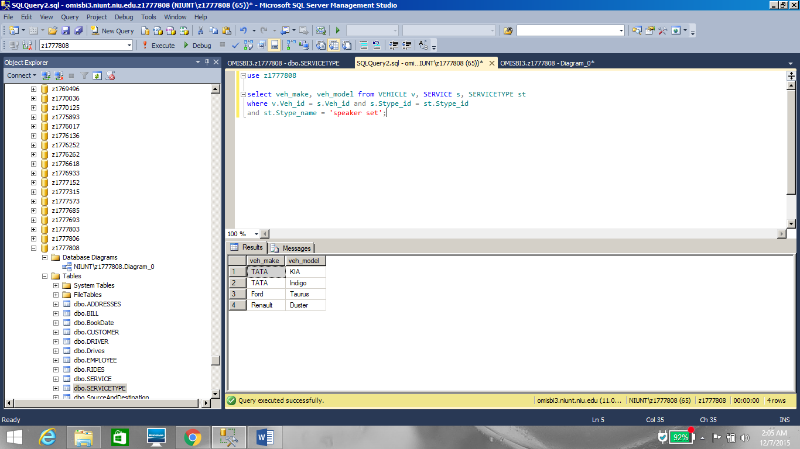

**Question 11**: Display the vehicle which is driven by maximum number of drivers.

**Importance**: To know favorite vehicle among the drivers so that we can add more of those vehicles.

**Query**: select Veh_make, Veh_model,count(dr.Dr_id) as NumberofDrivers from VEHICLE v, Drives dr

where v.Veh_id = dr.Veh_id

group by Veh_make, Veh_model

having count(dr.Dr_id) in (select TOP 1 count(dr.Dr_id) NumberofDrivers from VEHICLE v, Drives dr

where v.Veh_id = dr.Veh_id

group by Veh_make, Veh_model

order by 1 desc)

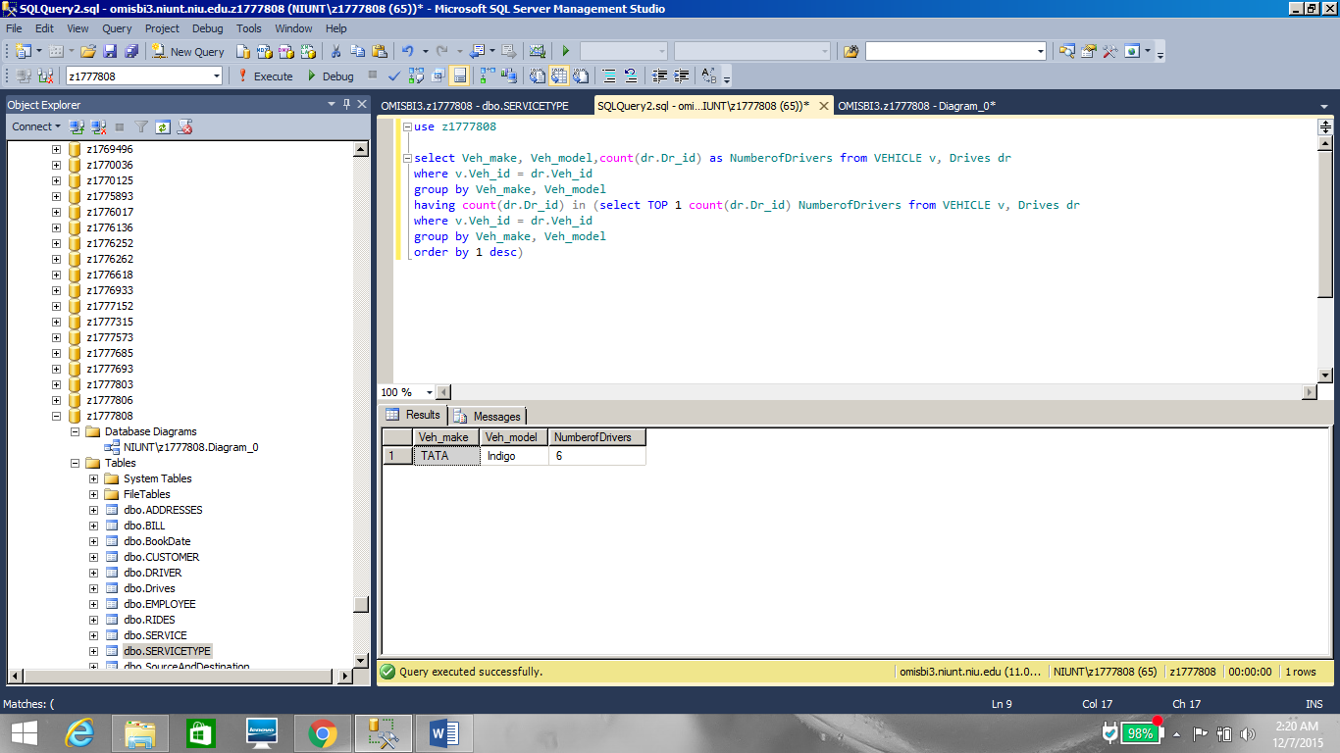

**Question 12**: Insert a New vehicle into Vehicle’s Table

**Importance**: Company bought a new vehicle, so adding it to the Database

**Query**: insert into VEHICLE values ('600','1290','Honda','Civic');

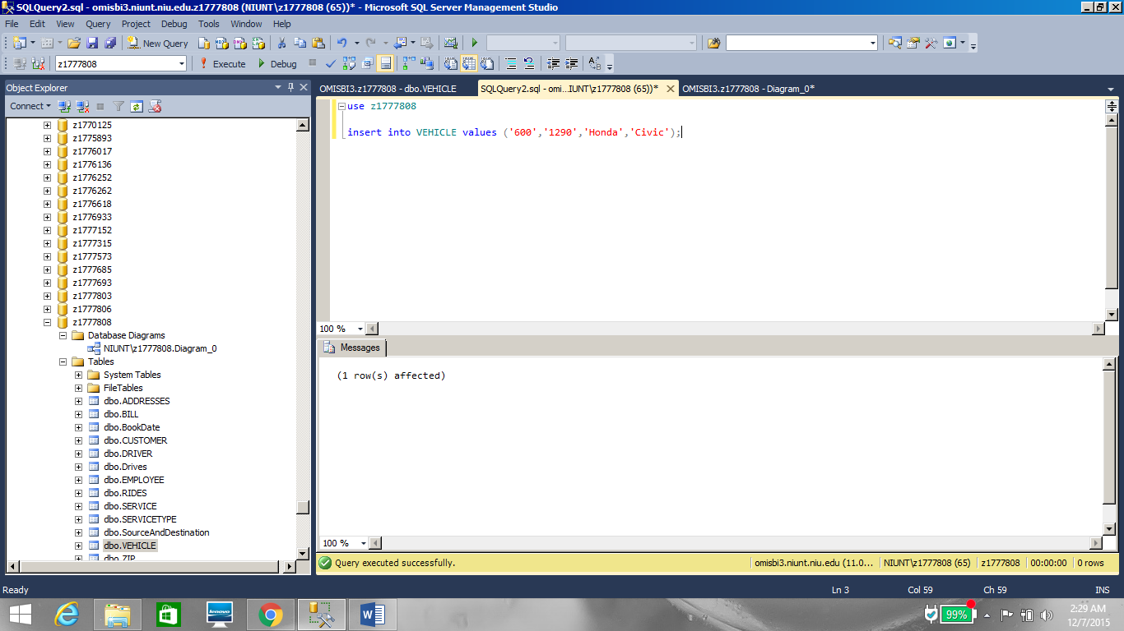

**Question 13**: Update the Contact number of Driver Prithvi to ‘9782635377’

**Importance**: Driver has lost his previous number, So we are updating his new number to the database.

**Query**: Update DRIVER

set Dr_contact = '9782635377'

where Dr_name = 'Prithvi'

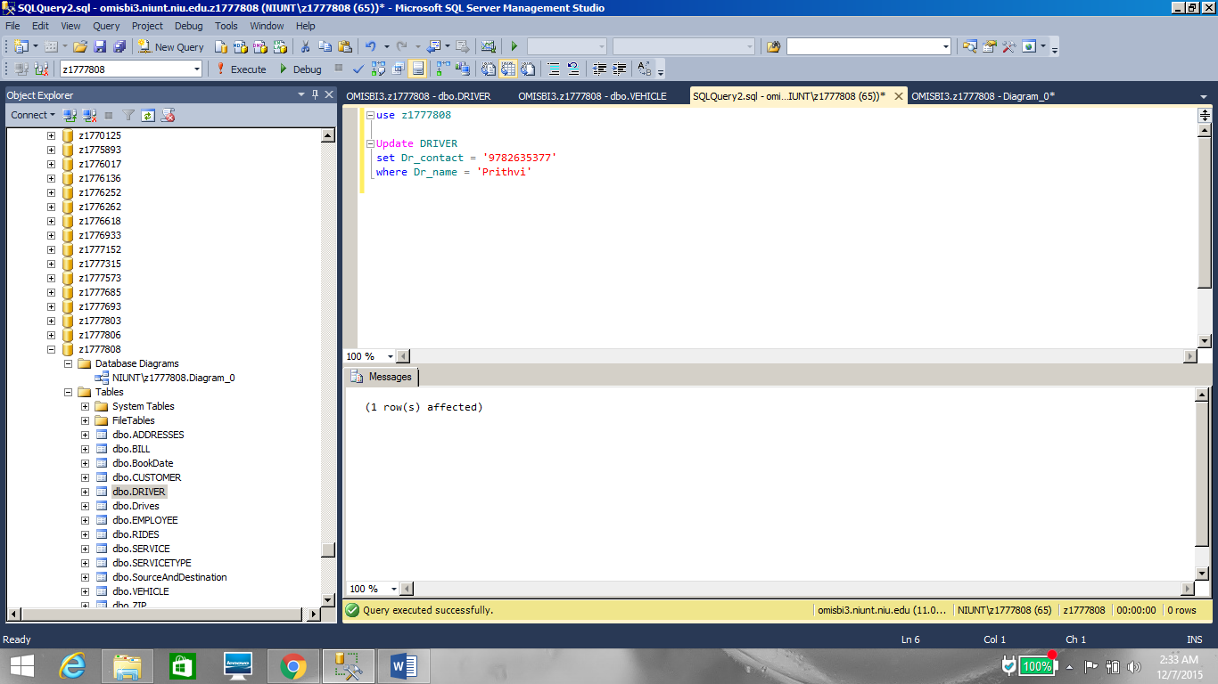

**Question 14**: Display the Service types which are not used by any vehicles

**Importance**: To know the best maintained parts of the car which didn’t require any service

**Query**: select stype_id, stype_name from SERVICETYPE

where Stype_id not in (select Stype_id from SERVICE);

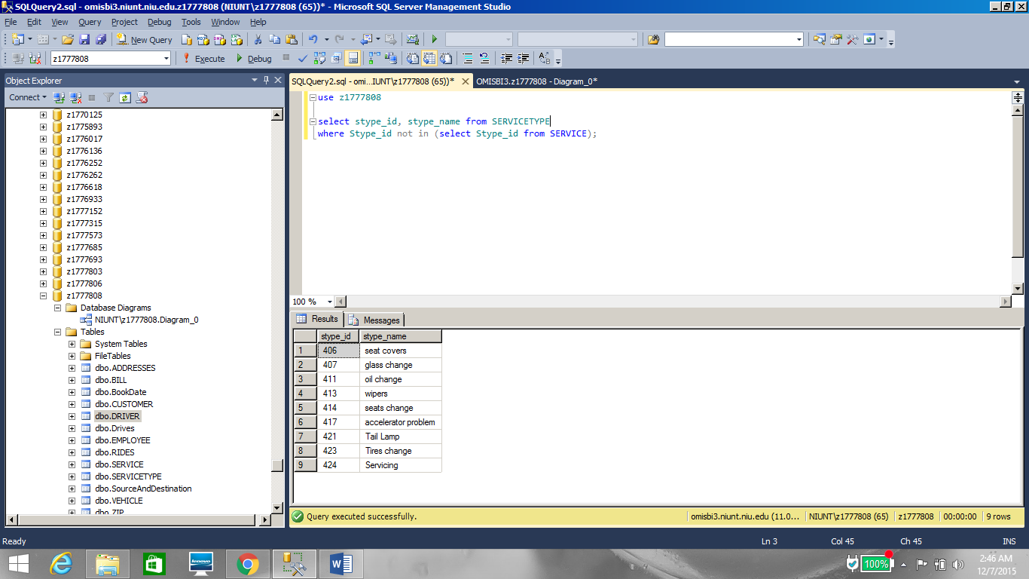

**Question 15**: Display the name of the City which doesn’t have a customer

**Importance**: To increase the marketing activities in those areas.

**Query**: select distinct City from zip z, CUSTOMER c

where z.Zipcode not in (select Cus_zipcode from CUSTOMER);

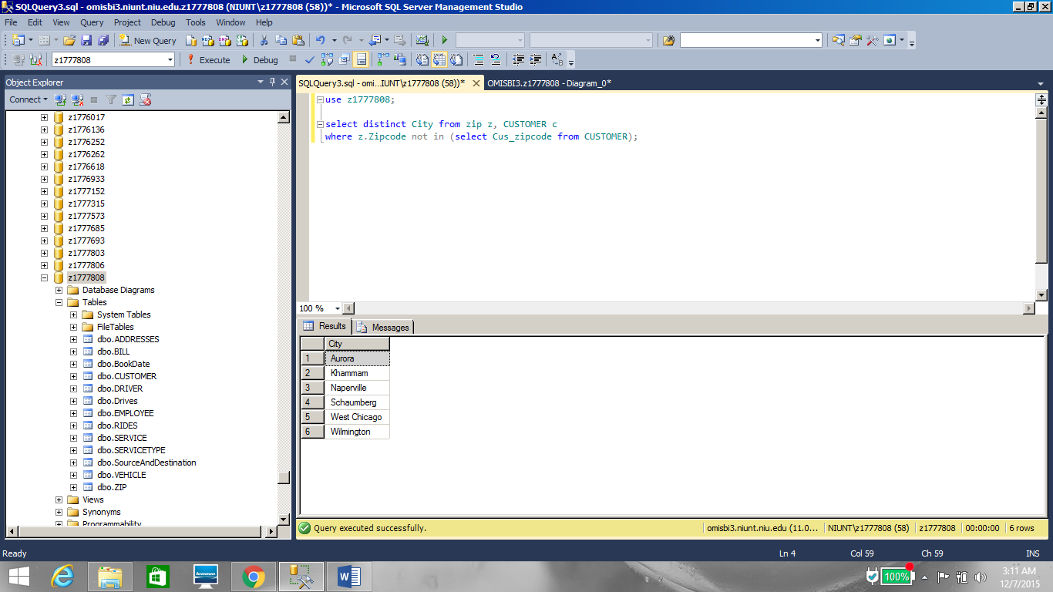

**Question 16**: Display the details of the longest ride

**Importance**: To check if the driver is working overtime.

**Query**: select Bill_num, c.Cust_id,cust_fname,cust_lname, r.Ride_id, bill_amount, bill_date, Ride_duration from BILL b, RIDES r,CUSTOMER c

where b.Ride_id = r.Ride_id and c.Cust_id = b.Cust_id

and Ride_duration in (select MAX(Ride_duration) from RIDES);

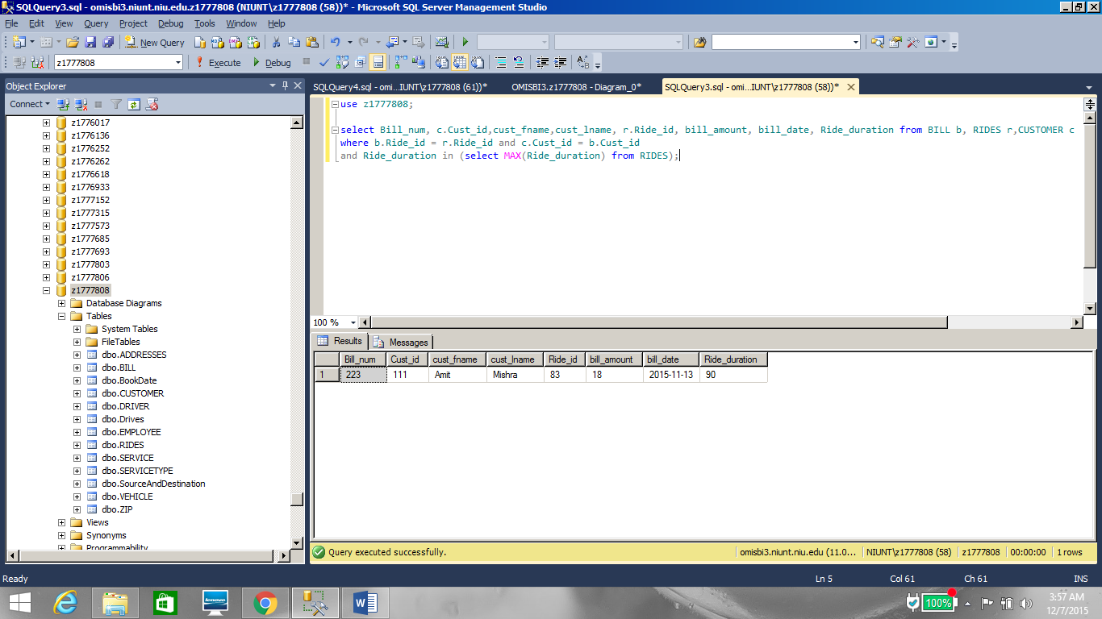

**Question 17**: Display the Source addresses for last ten rides.

**Importance**: To know recently popular pickup spots.

**Query**: select Source_id, Address from SourceAndDestination sad, ADDRESSES ad

where ad.Address_id = sad.Source_id and Start_time in (select top 10 Start_time from SourceAndDestination

order by Start_time desc);

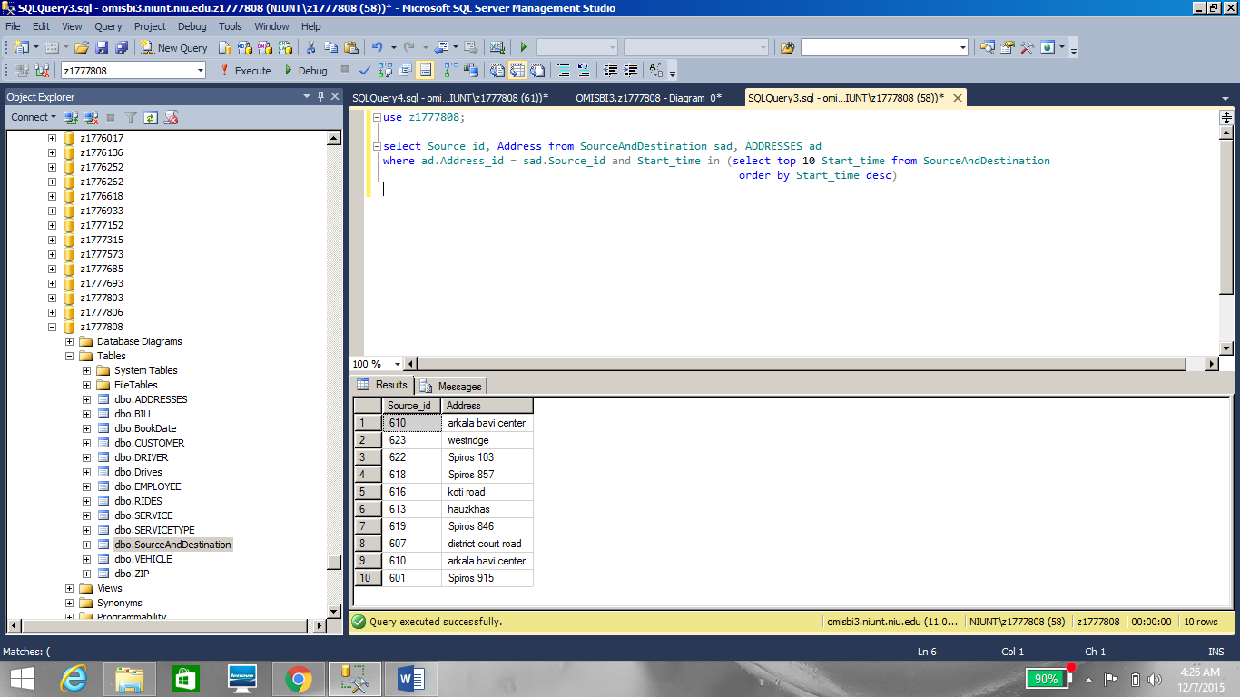

**Question 18**: Display the Bill amounts of the rides on Oct 24th 2015

**Importance**: Because we got a traffic ticket so we are just verifying what vehicles were there on that day and calculating if it was a profitable day or not.

**Query**: select bill_amount, Ride_id from BILL where Bill_date = '10-24-2015'

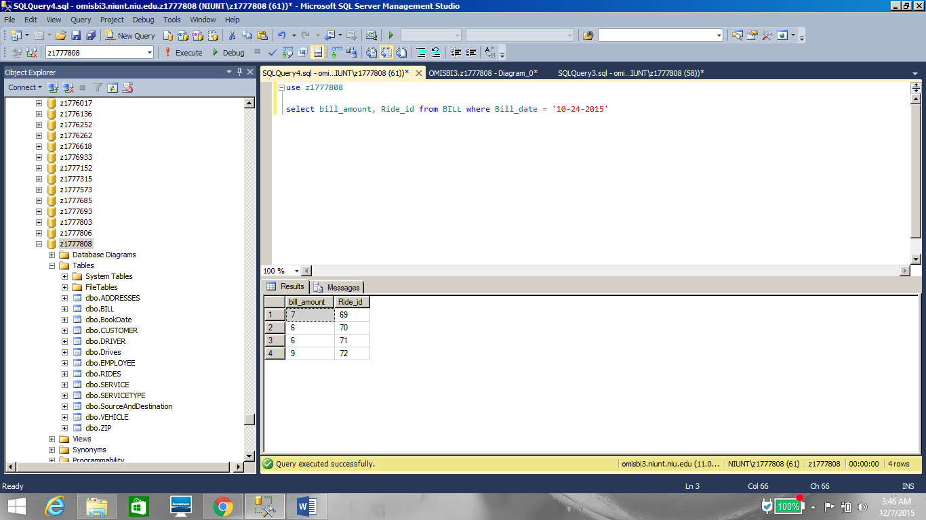

**Question 19**: Display the name of the Driver who have driven the vehicle ‘Nissan Maxima’

**Importance**: Because the vehicle is damaged so we need to interview all the drivers for the reason.

**Query**: select dr_name from DRIVER d, Drives dr, VEHICLE v

where d.Dr_id = dr.Dr_id and dr.Veh_id = v.Veh_id

and veh_make = 'Nissan' and veh_model = 'Maxima';

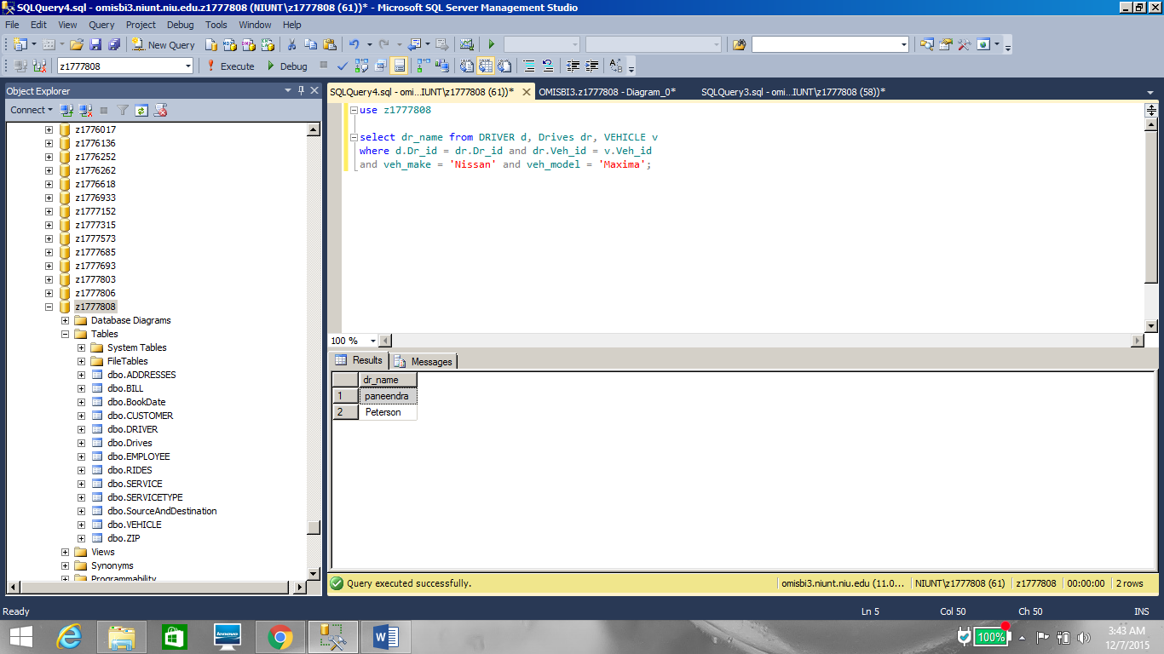

**Question 20**: Display the names of the customer who went to ride on vehicle ‘Ford Taurus’

**Importance**: Because they used the fake currency to make the payment, police has requested for his details.

**Query**: select cust_fname, cust_lname from CUSTOMER c, BookDate b, VEHICLE v

where c.Cust_id = b.Cust_id and b.Veh_id = v.Veh_id and

v.Veh_make = 'Ford' and v.Veh_model = 'Taurus';

